Hash Tables Results

Hash Tables: Quadratic Probing

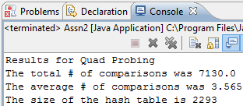

This was my best result for the Quadratic Probing. As you can see, the Average number of comparisons is under 4, and I was able to achieve the desired outcome of less than 2500 for my Hash Table’s Size.

Hash Tables: Double Hash

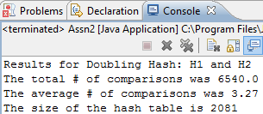

This was the best result for the Double Hashing, using my 1st and 2nd hash function.

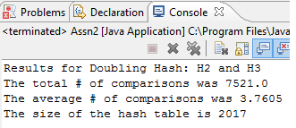

This was my best result for the Double Hashing, using my 2nd and 3rd hash function. (As you can see, it is much better than the 1st and 2nd)

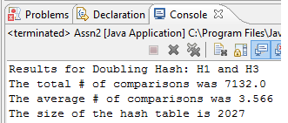

This was my best outcome for my 1st and 3rd hash function. It was in-between the 2nd and 3rd, and 1st and 2nd.

Hypothesis:  
  
These findings do in fact support the hypothesis that Double Hashing allows us to use smaller tables than Quadratic Probing. The hash functions that I used worked quite well, getting me very close to the amount of Aliases provided by the text file. In my testing, I believe my best outcome only had 17 empty spaces, which is pretty efficient.

Finding Hash Functions was a little difficult and I tried quite a few, but these are the ones that I found had the best/distinct results.

-Nicholas Smith